Estimated cost and schedules to use public transport from Chicago airports to South Bend:
From O’Hare: $5.00 for train to downtown Chicago (Ventra Ticket)
Ticket for South shore train: $14.25 (one way)
Taxi or Uber from SBN airport to Embassy Suites: ~15.00-25.00 (Eagle cab quote: $22.00—up to 4 passengers)
Chicago (ORD) to Embassy Suites total for public transport: ~$35.00-45.00

From Midway: $2.50 for train to downtown Chicago (Ventra Ticket)
Ticket for South shore train: $14.25 (one way)
Taxi or Uber from SBN airport to Embassy Suites: ~15.00-25.00 (Eagle cab quote: $22.00—up to 4 passengers)
Chicago (MDW) to Embassy Suites total for public transport: ~$32.00-42.00

South Shore Schedules from Millennium Station to SBN airport:

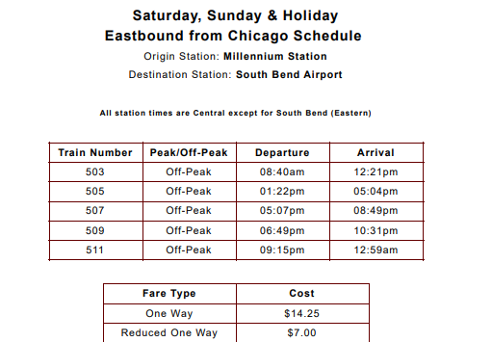

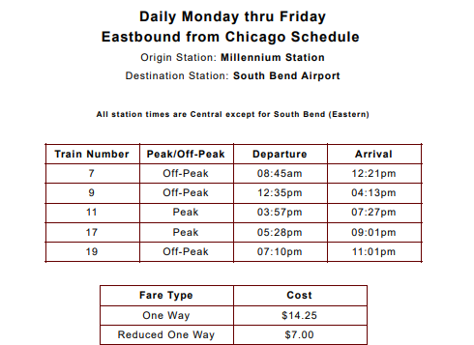
Qualifications for REDUCED FARES: Children under 14, Seniors 65 and Older, Passengers with Disabilities

Our hotel has recommended Eagle Cab: https://eaglecabsouthbend.com/

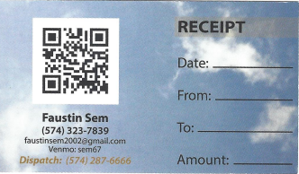

This cab service also provides service to/from the Chicago airports. This could be an option if multiple people fly into Chicago around the same time.

Uber and Lyft also available and could be less expensive, depending on day/time.

Other tips:
- How-to guides for Chicago Transit Authority: https://www.transitchicago.com/howto/
- If you are planning on spending additional time in Chicago, you may want to consider looking at the different options for CTA travel passes. In general, costs are $2.50/one way from Midway, O’Hare has a surcharge and one-way is $5, and 1-day pass is same price.
- Consider downloading app for South Shore: https://www.mysouthshoreline.com/mobile-app/
- If using Eagle Cab taxi service, book your taxi in advance for SBN airport travel.

